Clean Code Principles - Write Pure Functions
# Source: AI Source: Provided by: [Data Path: Persons Table -> ID Column: 1, Name_En Column: Motasem Essam] -> From: [Chatgpt (GPT‑5 Mini)] on [12/9/2025]
A pure function is a function that:
- Always returns the same output for the same input
- Has no side effects (doesn’t modify external state, global variables, or I/O)
Pure functions are predictable, easy to test, and easier to reason about.

🔑 Why Pure Functions Matter
# Source: AI Source: Provided by: [Data Path: Persons Table -> ID Column: 1, Name_En Column: Motasem Essam] -> From: [Chatgpt (GPT‑5 Mini)] on [12/9/2025]
- Easier to test and debug
- Reduces unexpected side effects
- Improves readability and maintainability
- Encourages functional programming best practices

❌ Bad Example (Impure Function)
# Source: AI Source: Provided by: [Data Path: Persons Table -> ID Column: 1, Name_En Column: Motasem Essam] -> From: [Chatgpt (GPT‑5 Mini)] on [12/9/2025]
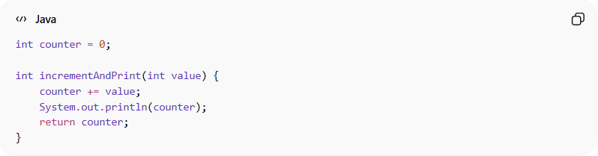
int counter = 0;

int incrementAndPrint(int value) {
counter += value;
System.out.println(counter);
return counter;
}
👉 Problems:
- Depends on external variable counter
- Prints to console (side effect)
- Returns different results for the same input

✅ Good Example (Pure Function)
# Source: AI Source: Provided by: [Data Path: Persons Table -> ID Column: 1, Name_En Column: Motasem Essam] -> From: [Chatgpt (GPT‑5 Mini)] on [12/9/2025]
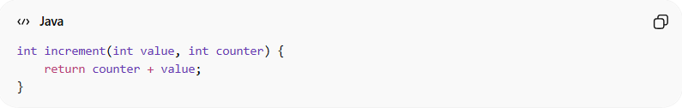
int increment(int value, int counter) {
return counter + value;
}
✅ Benefits:
- Always returns same output for same inputs
- No external side effects
- Easy to test and reuse

❌ Another Bad Example
# Source: AI Source: Provided by: [Data Path: Persons Table -> ID Column: 1, Name_En Column: Motasem Essam] -> From: [Chatgpt (GPT‑5 Mini)] on [12/9/2025]
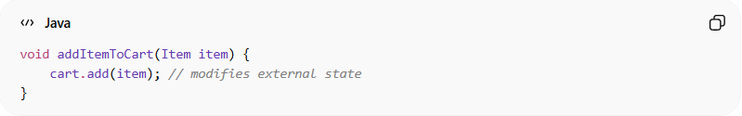
void addItemToCart(Item item) {
cart.add(item); // modifies external state
}

✅ Pure Alternative
# Source: AI Source: Provided by: [Data Path: Persons Table -> ID Column: 1, Name_En Column: Motasem Essam] -> From: [Chatgpt (GPT‑5 Mini)] on [12/9/2025]
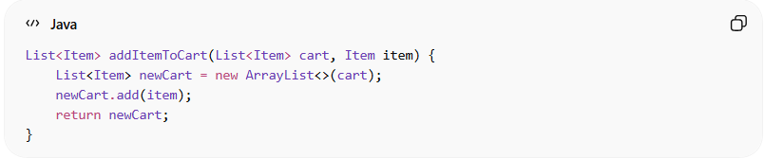
List<Item> addItemToCart(List<Item> cart, Item item) {
List<Item> newCart = new ArrayList<>(cart);
newCart.add(item);
return newCart;
}
✅ Benefits:
- Original cart is unchanged
- Predictable behavior
- Easy to test

💡 Key Idea
# Source: AI Source: Provided by: [Data Path: Persons Table -> ID Column: 1, Name_En Column: Motasem Essam] -> From: [Chatgpt (GPT‑5 Mini)] on [12/9/2025]
Keep functions predictable and side-effect free whenever possible.
If a function must have side effects (like saving to DB), clearly separate it from pure logic.

🚫 Common Mistakes
# Source: AI Source: Provided by: [Data Path: Persons Table -> ID Column: 1, Name_En Column: Motasem Essam] -> From: [Chatgpt (GPT‑5 Mini)] on [12/9/2025]
- Modifying global variables
- Changing object properties passed as arguments
- Performing I/O (printing, logging) inside the function
- Mixing computation and side effects

🧾 Summary
# Source: AI Source: Provided by: [Data Path: Persons Table -> ID Column: 1, Name_En Column: Motasem Essam] -> From: [Chatgpt (GPT‑5 Mini)] on [12/9/2025]
Pure functions help you write clean, maintainable, and testable code, making your programs easier to reason about and safer to refactor.

